24.12: a) For two concentric spherical shells, the capacitance is:
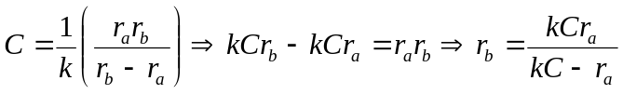
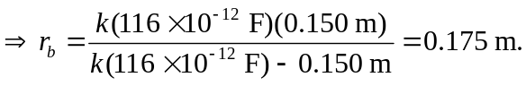
b)

